

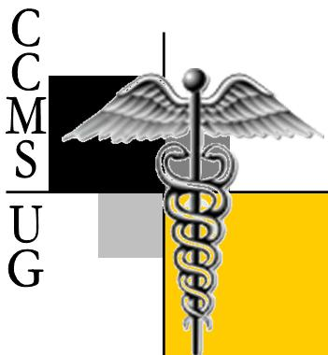
™
™
Are you a dreamer? Do you have a dream? What drives you towards success? Do you have a controlled passion? Are you constructively aggressive? What is your focus? Are you focused? How do you handle life’s unexpected trials? How do you handle life? Are you allowing your character to continuously be refined and molded? Are you a student and teacher? Are you humble?
Are you ready for medicine?
Is medicine ready for you?

University of Milwaukee- Wisconsin
Student Union Rm. 375
2200 E. Kenwood Blvd.
Milwaukee, WI 53211
C/o Alicia Armstrong, Founder/President

Phone: 414-248-0028
Email: Aliciaa2@uwm.edu
http://ccmsy.tripod.com

© & TM 2006 Cream City Medical Society Undergraduate Chapters. All rights reserved. CCMS-UG logo is a trademark of Cream City Medical Society Undergraduate Chapters.

Cream City Medical Society
Undergraduate Chapter at UW-Milwaukee
Changing & Molding Our Environment.

Today’s youth, tomorrow's leaders
Always, Striving for Inner Perfection.
Cream City Medical Society
Undergraduate Chapter at UW- Milwaukee
Changing & Molding Our Environment.



Our Commitment:
CCMS-UG sees the need for an effective, a powerful minority youth. CCMS-UG is dedicated to nourishing and guiding that youth. We also dedicated ourselves to making sure students understand they can dream, and make their dreams a reality. Mental, emotional, social and communal support is a key part of our group. We understand that ministering to the publics’ health is an honor, a gift which should be driven by a passion from within. CCMS-UG is set up to make sure students continue to dream, set and accomplish goals, and to mold their environment by providing students with: tutoring, mentoring, career services, study sessions, academic accountability, fellowship with minority doctors, shadowing and volunteer opportunities, preparations for medical school, seminars, opportunities to mentor high school students, and various trips.

Our History:

Cream City Medical Society Undergraduate Chapter is an affiliate of Cream City Medical Society, (est. 1927) of Wisconsin. Their focus is to address various health disparities among minorities within Milwaukee, WI. The name Cream City originated from a type of cream colored brick that was once used to build the city of Milwaukee in the early 20th century. This type of brick earned Milwaukee one of its early nicknames, “Cream City”. This “cream brick” is unique in its strength, beauty and ability to weather any storm.
This inspired a group of African-American physicians in 1927 to name their newly formed organization the Cream City Medical Society (CCMS). Like the brick, the organization has weathered its share of storms in Milwaukee, acting as a beacon of support and camaraderie for African-American physicians practicing medicine in the face of prejudice and discrimination.
Cream City Medical Society Undergraduate Chapter shares the same struggles and dreams; however, focusing the support on students at the pre-med level.

Our Mission:

Our mission is to support students with their academics, support them socially, morally and culturally by encouraging and displaying a positive image of the underrepresented community’s role in the healthcare field.

What We Offer:

- Providing students with personal one-on-one assists in creating Medical School Portfolios.
- Providing Personal Growth Seminars & Workshops.
- Providing Community Services Opportunities.
- Providing Academic and Professional Opportunities to attend local and national events such as CCMS meetings, National Medical Association Conference (SNMA), and much more...
University of Milwaukee- Wisconsin
Student Union Rm. 375
2200 E. Kenwood Blvd.
Milwaukee, WI 53211
C/o Alicia Armstrong
Founder/President

© & TM 2006 Cream City Medical Society Undergraduate Chapters. All rights reserved. CCMS-UG logo is a trademark of Cream City Medical Society Undergraduate Chapters.
™

